What if analysis - Data Tables

We can use What-if Analysis to generate data tables. Type of data table are one-variable data table and two-variable data table. Assume you own a book store and have 100 books in storage. You sell a certain % for the highest price of $50 and a certain % for the lower price of $20. If you sell 60% for the highest price, cell D10 below calculates a total profit of 60 * $50 + 40 * $20 = $3800.

One Variable Data Table

1. Assume we have the data shown in below, select cell B12 and type =D10 (refer to the total profit cell).

2. Type the different percentages in column A.

3. Select the range A12:B17.

We can calculate the total profit if we sell 60% for the highest price, 70% for the highest price, etc.

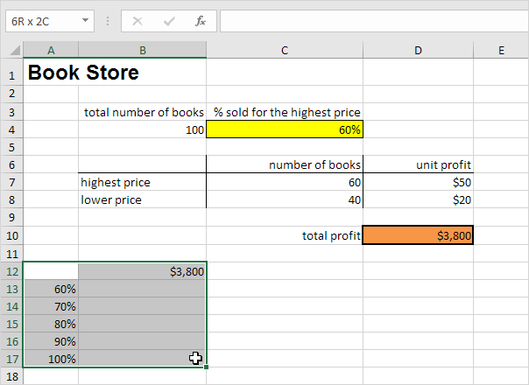

4. On the Data tab, in the Forecast group, click What-If Analysis.



5. Click Data Table.

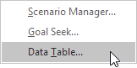

6. Click in the 'Column input cell' box (the percentages are in a column) and select cell C4.

We select cell C4 because the percentages refer to cell C4 (% sold for the highest price). Together with the formula in cell B12, Excel now knows that it should replace cell C4 with 60% to calculate the total profit, replace cell C4 with 70% to calculate the total profit, etc.

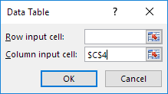

Note: this is a one variable data table so we leave the Row input cell blank.

7. Click OK.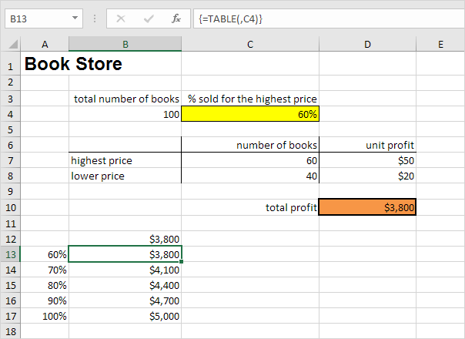

Conclusion: Sale of 60% for the highest price will yield total profit of $3800, where 70% sale for the highest price, you obtain a total profit of $4100, etc.

### Two Variable Data Table

1. By using back the data provided above, select cell A12 and type =D10 (refer to the total profit cell).

2. Type the different unit profits (highest price) in row 12.

3. Type the different percentages in column A.

4. Select the range A12:D17.

We are going to calculate the total profit for the different combinations of 'unit profit (highest price)' and '% sold for the highest price'.

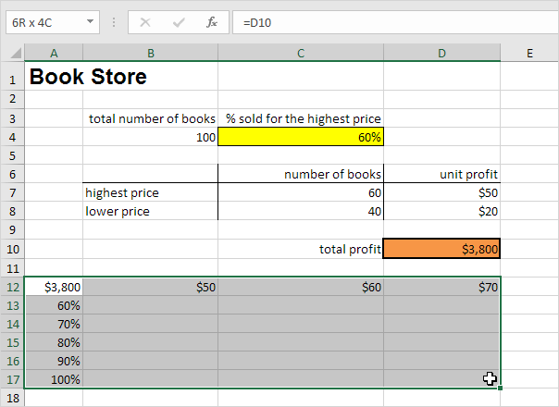

5. On the Data tab, in the Forecast group, click What-If Analysis.



6. Click Data Table.



7. Click in the 'Row input cell' box (the unit profits are in a row) and select cell D7.

8. Click in the 'Column input cell' box (the percentages are in a column) and select cell C4.

We select cell D7 because the unit profits refer to cell D7. We select cell C4 because the percentages refer to cell C4. Together with the formula in cell A12, Excel now knows that it should replace cell D7 with $50 and cell C4 with 60% to calculate the total profit, replace cell D7 with $50 and cell C4 with 70% to calculate the total profit, etc.

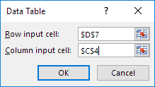

9. Click OK.

Result.

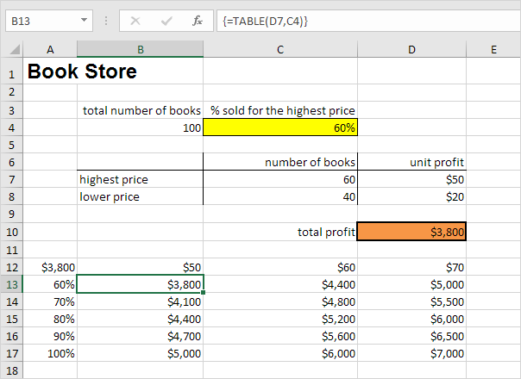

Conclusion: if you sell 60% for the highest price, at a unit profit of $50, you obtain a total profit of $3800, if you sell 80% for the highest price, at a unit profit of $60, you obtain a total profit of $5200, etc.

What if analysis – Goal Seek

We can use What-if Analysis to help get a goal value. We will use this tool to help generate the grade needed for a student in order to get a certain final result.

1. Assume we have this data. The value of Exam 4 is the one that needed to be calculated, where Final grade is the resulting value from average of 4 exams (formula in formula bar).

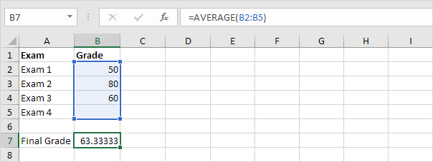

2. The current final grade is 63.33, and we want to achieve 70.

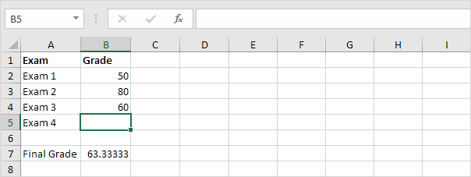

3. On the Data tab, in the Forecast group, click What-If Analysis.



4. Click Goal Seek.

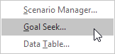

The Goal Seek dialog box appears.

5. Select cell B7.

6. Click in the 'To value' box and type 70.

7. Click in the 'By changing cell' box and select cell B5.

8. Click OK.

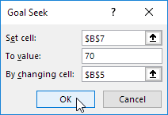

Result. A grade of 90 on the fourth exam produces a final grade of 70.

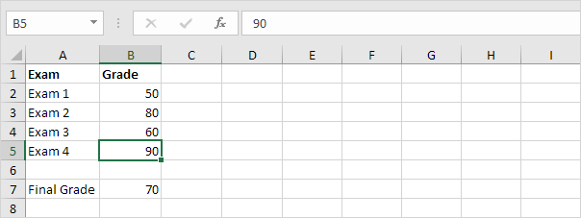

Solver

Excel’s solver function can help us to generate the optimal model. We can feed in data to Excel and it will help us to either maximise or minimise the result.

### Formulate the Model

The model we are going to solve looks as follows in Excel.

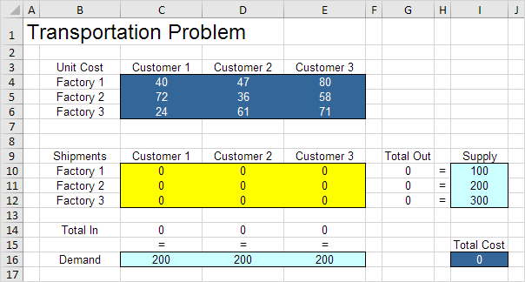

1. To formulate this **transportation problem**, answer the following three questions.

a. These are the values to be generate: how many unit to be send from each factory to each customer.

b. These are the constraints. Each of the factory has a fixed number of supply, and each customer has fixed demand for product.

c. This is the measure of performance. In this case it is the total cost, where we want to minimise it.

2. To make the model easier to understand, we can define name for these values.

|  |  |
| --- | --- |
| **Range Name** | **Cells** |
| UnitCost | C4:E6 |
| Shipments | C10:E12 |
| TotalIn | C14:E14 |
| Demand | C16:E16 |
| TotalOut | G10:G12 |
| Supply | I10:I12 |
| TotalCost | I16 |

3. We need to feed in the formula for Excel in order to generate result.

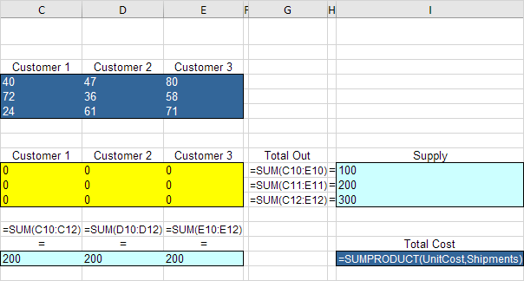

Explanation: The SUM functions calculate the total shipped from each factory (Total Out) to each customer (Total In). Total Cost equals the sumproduct of UnitCost and Shipments.

### Trial and Error

With this formulation, it becomes easy to analyze any trial solution.

For example, if we ship 100 units from Factory 1 to Customer 1, 200 units from Factory 2 to Customer 2, 100 units from Factory 3 to Customer 1 and 200 units from Factory 3 to Customer 3, Total Out equals Supply and Total In equals Demand. This solution has a total cost of 27800.

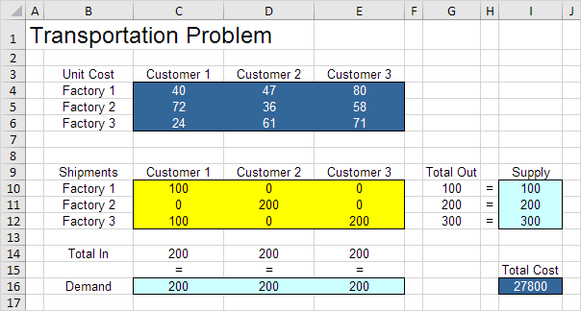

It is not necessary to use trial and error. We shall describe next how the **Excel Solver** can be used to quickly find the optimal solution.

### Solve the Model

To find the optimal solution, execute the following steps.

1. On the Data tab, in the Analyze group, click Solver.

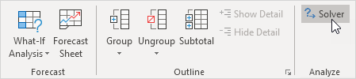

Note: can't find the Solver button? Click here to load the [Solver add-in](https://www.excel-easy.com/data-analysis/solver.html#load-solver-add-in).

Enter the solver parameters (read on). The result should be consistent with the picture below.

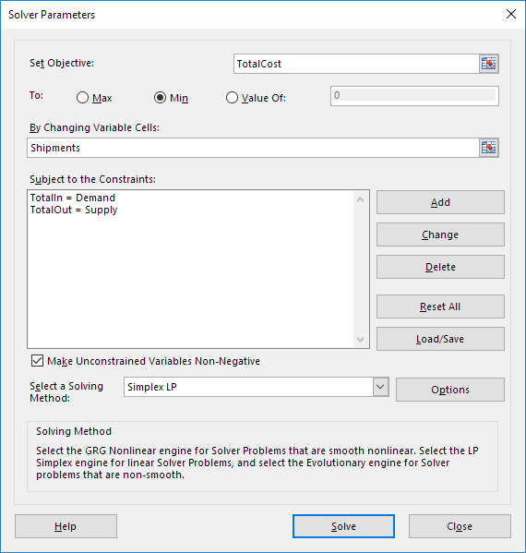

You have the choice of typing the range names or clicking on the cells in the spreadsheet.

2. Enter TotalCost for the Objective.

3. Click Min.

4. Enter Shipments for the Changing Variable Cells.

5. Click Add to enter the following constraint.

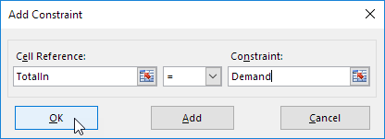

6. Click Add to enter the following constraint.

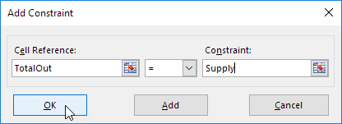

7. Check 'Make Unconstrained Variables Non-Negative' and select 'Simplex LP'.

8. Finally, click Solve.

Result:

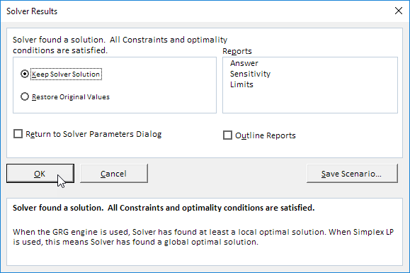

The optimal solution:

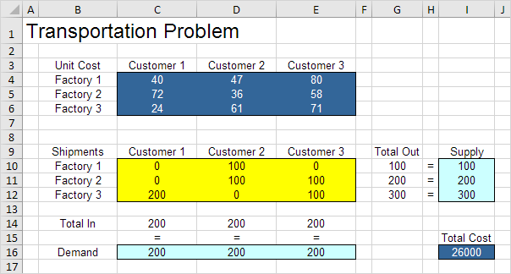

Conclusion: it is optimal to ship 100 units from Factory 1 to Customer 2, 100 units from Factory 2 to Customer 2, 100 units from Factory 2 to Customer 3, 200 units from Factory 3 to Customer 1 and 100 units from Factory 3 to Customer 3. This solution gives the minimum cost of 26000. All constraints are satisfied.

Analysis ToolPak – installation

Analysis ToolPak is an Add-in for Excel. It is capable to generate histogram, ANOVA test, t-Test, f-Test and more. We will introduce t-Test and Correlation.

To load the Analysis ToolPak add-in, execute the following steps.

1. On the File tab, click Options.

2. Under Add-ins, select Analysis ToolPak and click on the Go button.

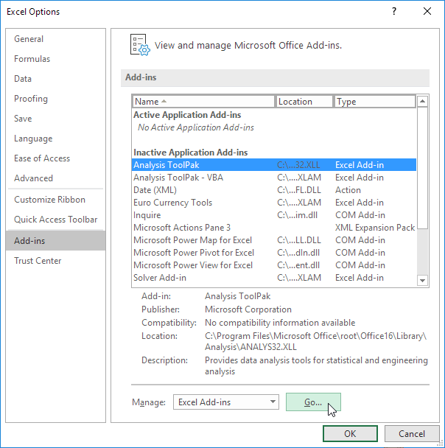

3. Check Analysis ToolPak and click on OK.

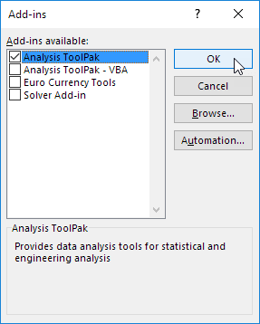

4. On the Data tab, in the Analysis group, you can now click on **Data Analysis**.

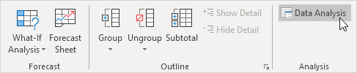

The following dialog box below appears.

5. For example, select Histogram and click OK to create a Histogram in Excel.

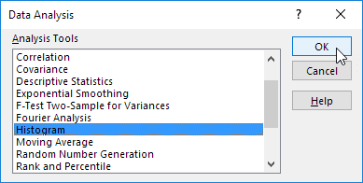

Analysis ToolPak – t-Test

The t-Test is used to test the null hypothesis that the means of two populations are equal.

Below you can find the study hours of 6 female students and 5 male students.

H0: μ1 - μ2 = 0  
H1: μ1 - μ2 ≠ 0

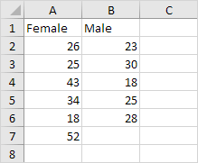

To perform a t-Test, execute the following steps.

1. First, perform an [F-Test](https://www.excel-easy.com/examples/f-test.html) to determine if the variances of the two populations are equal. This is not the case.

2. On the Data tab, in the Analysis group, click Data Analysis.

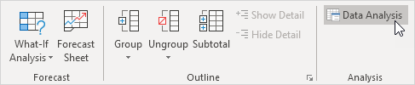

3. Select t-Test: Two-Sample Assuming Unequal Variances and click OK.

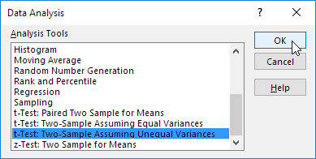

4. Click in the Variable 1 Range box and select the range A2:A7.

5. Click in the Variable 2 Range box and select the range B2:B6.

6. Click in the Hypothesized Mean Difference box and type 0 (H0: μ1 - μ2 = 0).

7. Click in the Output Range box and select cell E1.

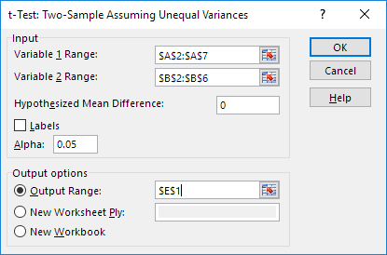

8. Click OK.

Result:

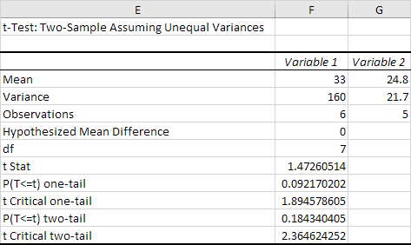

Conclusion: We do a two-tail test (inequality). lf t Stat < -t Critical two-tail or t Stat > t Critical two-tail, we reject the null hypothesis. This is not the case, -2.365 < 1.473 < 2.365. Therefore, we do not reject the null hypothesis. The observed difference between the sample means (33 - 24.8) is not convincing enough to say that the average number of study hours between female and male students differ significantly.

Analysis ToolPak - Correlation

1. On the Data tab, in the Analysis group, click Data Analysis.

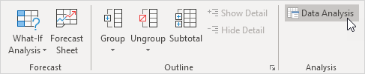

Note: can't find the Data Analysis button? Click here to load the [Analysis ToolPak add-in](https://www.excel-easy.com/data-analysis/analysis-toolpak.html).

2. Select Correlation and click OK.

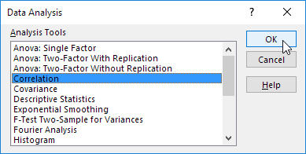

3. For example, select the range A1:C6 as the Input Range.

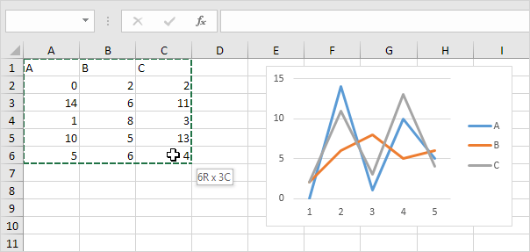

4. Check Labels in first row.

5. Select cell A8 as the Output Range.

6. Click OK.

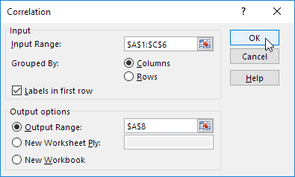

Result.

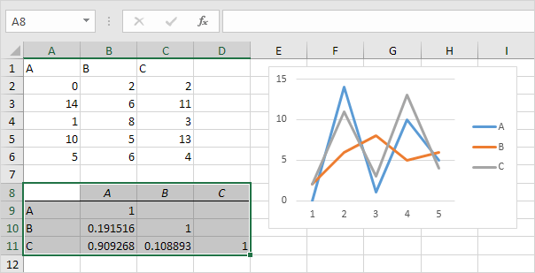

Conclusion: variables A and C are positively correlated (0.91). Variables A and B are not correlated (0.19). Variables B and C are also not correlated (0.11) . You can verify these conclusions by looking at the graph.